Hình 1: Bật máy 2

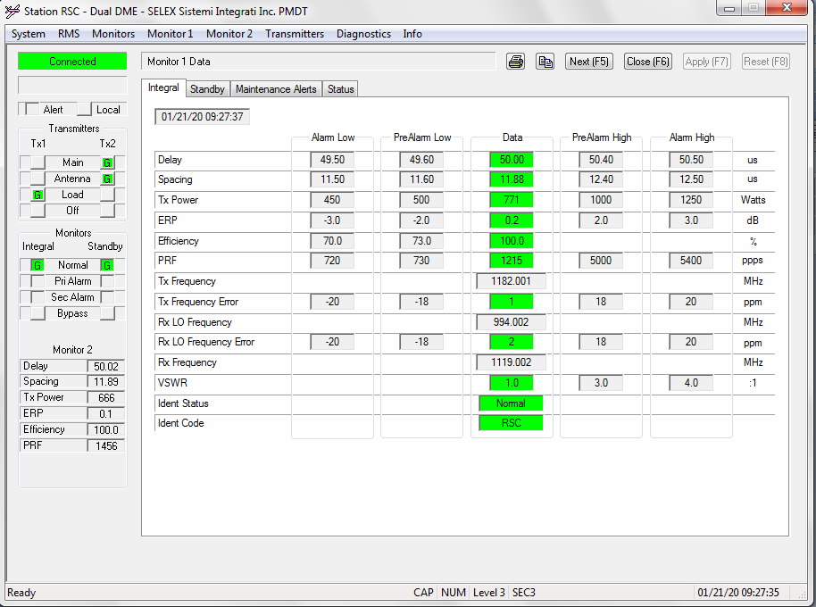

Ban tin:

[09:26:49.196] F8 F8 B0 F0 08 00 00 00 00 34 00 14 01 15 09 1B 23 00 00 80 07 00 00 01 8C 06 39 8A 01 19 BC 8A 13 A5 04 9A 02 E8 03 B0 05 00 00 00 00 00 00 00 00 00 00 06 01 00 00 06 00 00 C8 51 F3 D5 66 D7 15

Main Tx2

Ant Tx2

Tx1 LOAD

Tx1 ON

Tx2 ON

Ngay 21 thang 1 nam 20 Gio 9 Phut 27 Giay 35

DME Delay: 5002 us,Spacing: 1189 us,TxPower: 666 Watts,Efficiency :1000 %,PRF: 1456 ppps,ERP: 1

Hình 2 bật local lên, đèn alert sáng

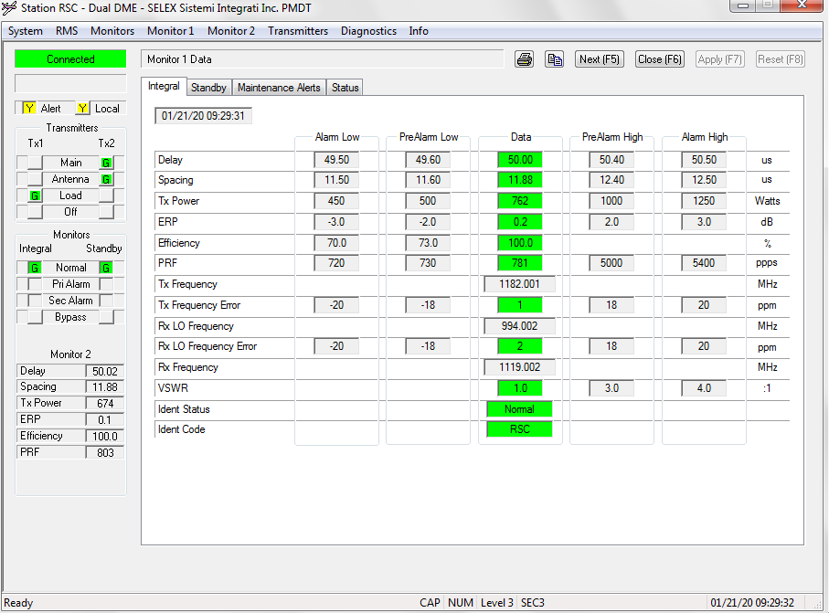

Bật local

[09:29:32.484]F8 F8 B0 F0 08 00 00 00 00 34 00 14 01 15 09 1E 12 00 00 81 07 00 00 11 8C 06 39 8A 01 19 BC 8A 13 A4 04 A2 02 E8 03 2C 03 00 00 00 00 00 00 00 00 00 00 06 01 00 00 06 00 00 42 18 33 D6 66 AB 91

*Alert*

*Local*

*Main Tx2*

*Ant Tx2*

*Tx1 LOAD*

*Tx1 ON*

*Tx2 ON*

*Ngay 21 thang 1 nam 20 Gio 9 Phut 30 Giay 18*

*DME Delay: 5002 us,Spacing: 1188 us,TxPower: 674 Watts,Efficiency :1000 %,PRF: 812 ppps,ERP: 1*

Hình 3 : Tắt local và bật sang máy 1

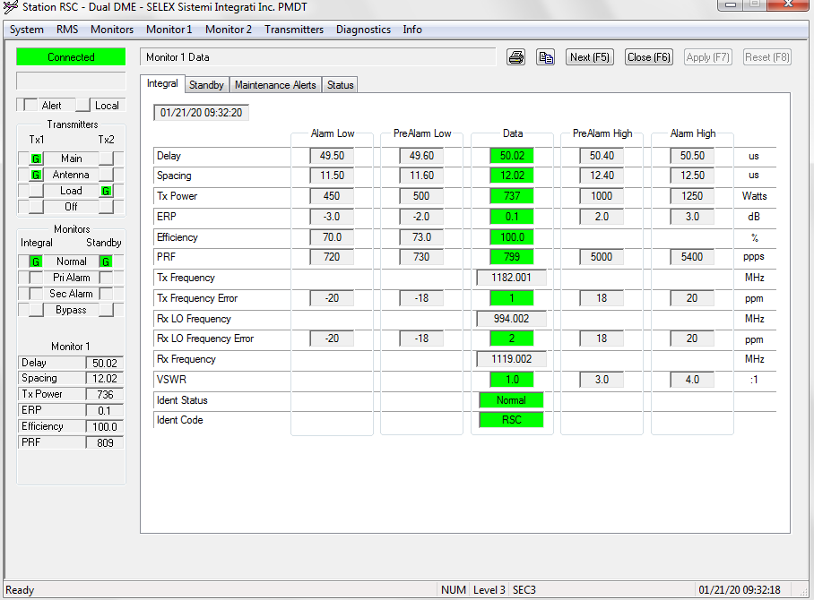

[09:32:04.762] F8 F8 B0 F0 08 00 00 00 00 34 00 14 01 15 09 20 32 00 00 80 27 00 00 01 8F 06 39 8A 01 19 BC 89 13 B2 04 DC 02 E8 03 0D 03 00 00 00 00 00 00 00 00 00 00 06 01 00 00 06 00 00 54 93 6E D6 66 67 AD

Giải nghĩa:

*Main Tx1*

*Ant Tx1*

*Tx2 LOAD*

*Tx1 ON*

*Tx2 ON*

*Ngay 21 thang 1 nam 20 Gio 9 Phut 32 Giay 50*

*DME Delay: 5001 us,Spacing: 1202 us,TxPower: 732 Watts,Efficiency :1000 %,PRF: 781 ppps,ERP: 1*

Hình 4.Bật bypass máy chính, Main = Tx2

S5 Khi bypass được bật thì máy sẽ chạy kể cả phát sinh lỗi

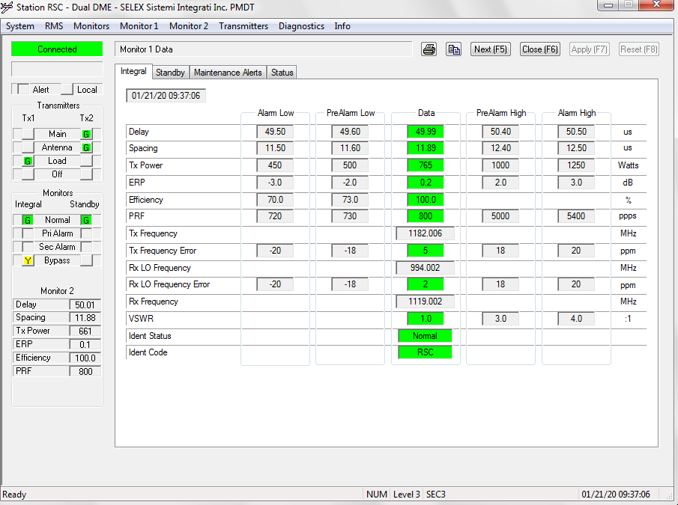

[09:36:51.241] F8 F8 B0 F0 08 00 00 00 00 34 00 14 01 15 09 25 24 00 00 80 07 04 00 01 9C 06 39 8A 01 19 BC 89 13 A5 04 91 02 E8 03 17 03 00 00 00 00 00 00 00 00 00 00 06 00 00 00 06 00 00 D8 78 DE D6 66 08 CE

Main Tx2

Ant Tx2

Tx1 LOAD

Tx1 ON

Tx2 ON

Integral Bypass

13b4 bypass all

Ngay 21 thang 1 nam 20 Gio 9 Phut 37 Giay 36

DME Delay: 5001 us,Spacing: 1189 us,TxPower: 657 Watts,Efficiency :1000 %,PRF: 791 ppps,ERP: 0

Hình 5: Máy chính, máy phụ bật bypass, Main = Tx2 (s6)

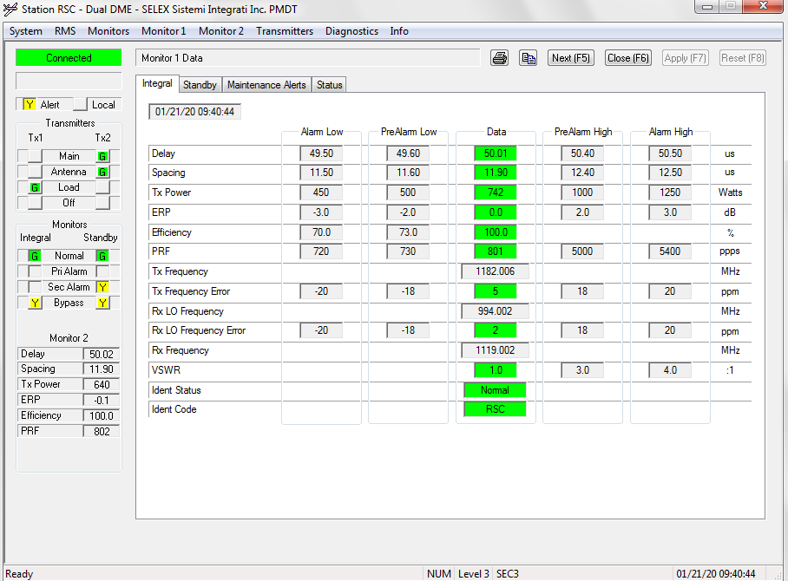

Có Alert, SecAlarm, Bypass máy chính, Bypass máy phụ

[09:40:27.641] F8 F8 B0 F0 08 00 00 00 00 34 00 14 01 15 09 29 0E 00 00 81 07 24 03 01 9C 06 39 8A 01 19 BC 8A 13 A6 04 77 02 E8 03 25 03 00 00 00 00 00 00 00 00 00 00 06 FF 00 00 06 00 00 1A FB 32 D7 66 54 EB

Alert

Main Tx2

Ant Tx2

Tx1 LOAD

Tx1 ON

Tx2 ON

Integral Bypass

Integral SecAlarm?

Standby SecAlarm

Standby Bypass

13b4 bypass all

Ngay 21 thang 1 nam 20 Gio 9 Phut 41 Giay 14

DME Delay: 5002 us,Spacing: 1190 us,TxPower: 631 Watts,Efficiency :1000 %,PRF: 805 ppps,ERP: -1

Hình 6: Máy chính, máy phụ bật bypass, Main = Tx2, Tx1 = OFF (s7)

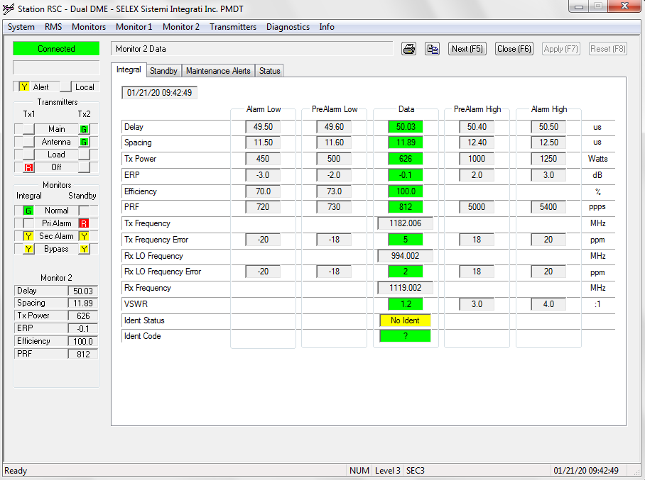

[09:42:07.313] F8 F8 B0 F0 08 00 00 00 00 34 00 14 01 15 09 2A 35 00 00 81 07 2C 03 01 98 06 39 8A 01 19 BC 8B 13 A6 04 71 02 E8 03 20 03 00 00 00 00 00 00 00 00 00 00 06 FF 00 00 06 00 00 68 E7 59 D7 66 BE 6E

Alert

Main Tx2

Ant Tx2

Tx1 OFF

Tx2 ON

Integral Bypass

Integral SecAlarm

Standby PriAlarm

Standby SecAlarm

Standby Bypass

13b4 bypass all

Ngay 21 thang 1 nam 20 Gio 9 Phut 42 Giay 53

DME Delay: 5003 us,Spacing: 1190 us,TxPower: 625 Watts,Efficiency :1000 %,PRF: 800 ppps,ERP: -1

Hình 7: chuyển từ hình 6 sang off2

Hay TX1 Off và TX2 off 2

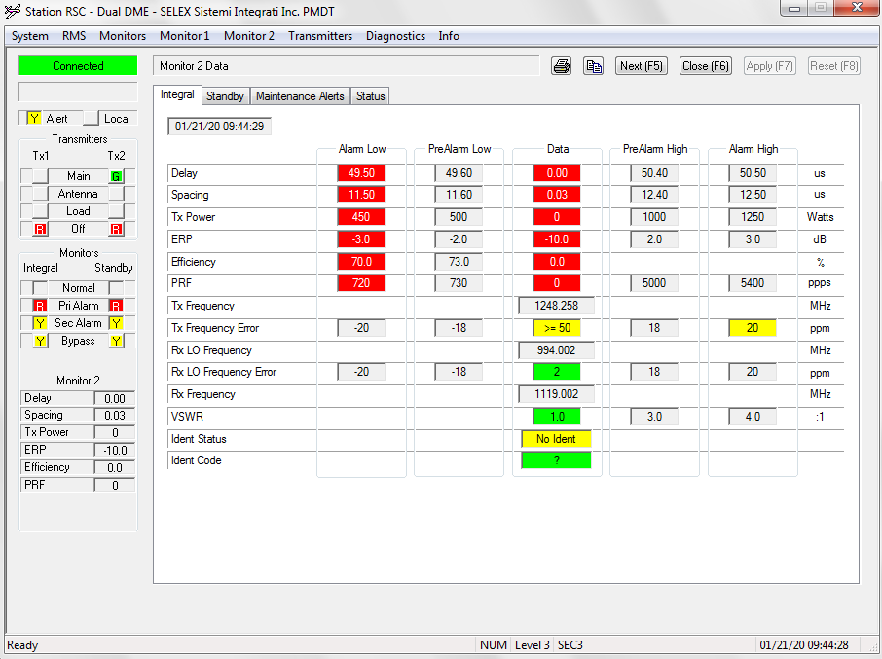

[09:54:16.838] F8 F8 B0 F0 08 00 00 00 00 34 00 14 01 15 09 37 02 00 00 81 07 2C 02 01 98 06 39 8A 01 19 BC 87 13 A5 04 89 02 E8 03 16 03 00 00 00 00 00 00 00 00 00 00 06 00 00 00 06 00 00 CF 18 94 D4 66 D4 95

Alert

Main Tx2

Ant Tx2

Tx1 OFF

Tx2 ON

Integral Bypass

Standby PriAlarm

Standby SecAlarm

Standby Bypass

13b4 bypass all

Ngay 21 thang 1 nam 20 Gio 9 Phut 55 Giay 2

DME Delay: 4999 us,Spacing: 1189 us,TxPower: 649 Watts,Efficiency :1000 %,PRF: 790 ppps,ERP: 0

* Bản tin này ko khớp ảnh này

Hình 8: Main = Tx2, bypass máy chính, Tx1 OFF (s8)

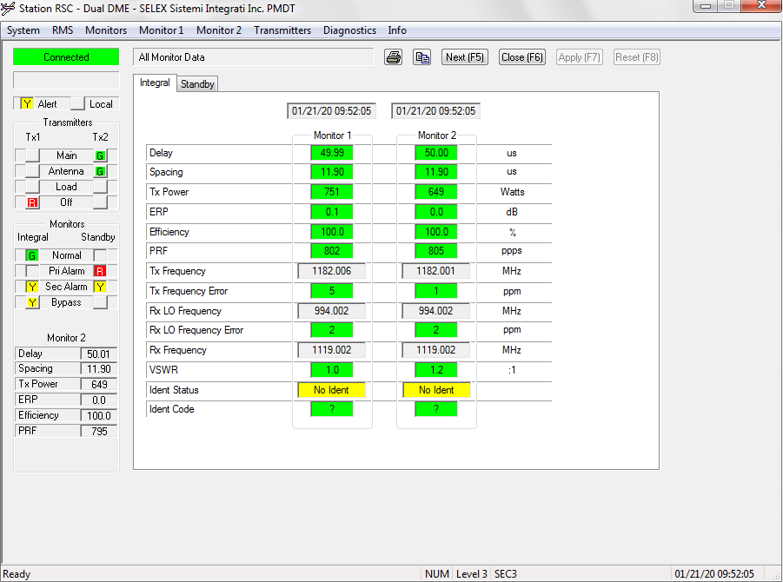

[09:52:05.349] F8 F8 B0 F0 08 00 00 00 00 34 00 14 01 15 09 34 32 00 00 81 07 0C 03 01 98 06 39 8A 01 19 BC 87 13 A5 04 8B 02 E8 03 29 03 00 00 00 00 00 00 00 00 00 00 06 00 00 00 06 00 00 57 76 43 D8 66 30 B5

Alert

Main Tx2

Ant Tx2

Tx1 OFF

Tx2 ON

Integral Bypass

Integral SecAlarm

Standby PriAlarm

Standby SecAlarm

13b4 bypass all

Ngay 21 thang 1 nam 20 Gio 9 Phut 52 Giay 50

DME Delay: 4999 us,Spacing: 1189 us,TxPower: 651 Watts,Efficiency :1000 %,PRF: 809 ppps,ERP: 0

S9 OFF 1 SANG OFFF HET

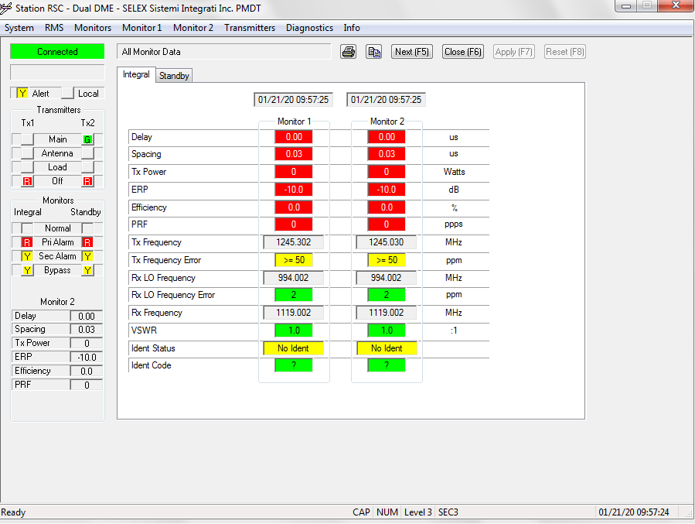

[09:55:43.483] F8 F8 B0 F0 08 00 00 00 00 34 00 14 01 15 09 38 1D 00 00 81 07 2D 03 01 90 06 39 8A 01 19 BC 00 00 03 00 00 00 00 00 00 00 00 00 00 00 00 00 00 00 00 00 06 9C 00 00 06 00 00 B4 EE B5 D4 66 7D 70

Alert

Main Tx2

Ant Tx2

Tx1 OFF

Tx2 OFF

Integral Bypass

Integral SecAlarm

Standby PriAlarm

Standby SecAlarm

Standby Bypass

13b4 bypass all

eOFF

No Go condition ALARM

Ngay 21 thang 1 nam 20 Gio 9 Phut 56 Giay 29

DME Delay: 0 us,Spacing: 3 us,TxPower: 0 Watts,Efficiency :0 %,PRF: 0 ppps,ERP: -100

S10

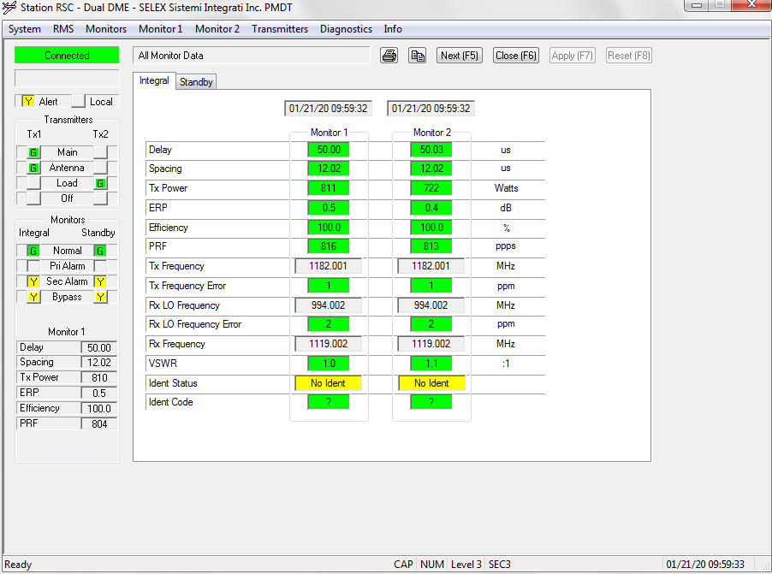

[09:58:11.737] F8 F8 B0 F0 08 00 00 00 00 34 00 14 01 15 09 3A 39 00 00 81 27 24 02 01 9F 06 39 8A 01 19 BC 89 13 B2 04 26 03 E8 03 1F 03 00 00 00 00 00 00 00 00 00 00 06 05 00 00 06 00 00 A5 D5 EF D4 66 76 91

Alert

Main Tx1

Ant Tx1

Tx2 LOAD

Tx1 ON

Tx2 ON

Integral Bypass

Standby SecAlarm

Standby Bypass

13b4 bypass all

eMain

No Go condition ALARM

Ngay 21 thang 1 nam 20 Gio 9 Phut 58 Giay 57

DME Delay: 5001 us,Spacing: 1202 us,TxPower: 806 Watts,Efficiency :1000 %,PRF: 799 ppps,ERP: 5

DUOI DAY LA S11

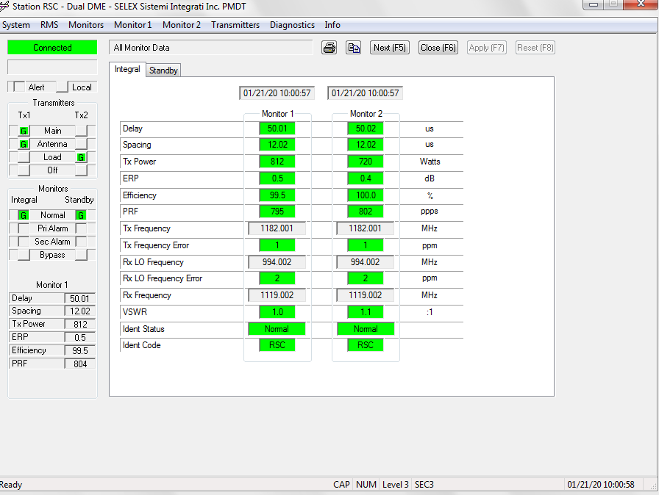

[09:59:51.427] F8 F8 B0 F0 08 00 00 00 00 34 00 14 01 15 0A 00 25 00 00 81 27 00 00 01 8F 06 39 8A 01 19 BC 89 13 B2 04 26 03 E8 03 1B 03 00 00 00 00 00 00 00 00 00 00 06 05 00 00 06 00 00 03 C3 16 D5 66 50 63

Alert

Main Tx1

Ant Tx1

Tx2 LOAD

Tx1 ON

Tx2 ON

eMain

Go condition

Ngay 21 thang 1 nam 20 Gio 10 Phut 0 Giay 37

DME Delay: 5001 us,Spacing: 1202 us,TxPower: 806 Watts,Efficiency :1000 %,PRF: 795 ppps,ERP: 5

V1 VOR TX1

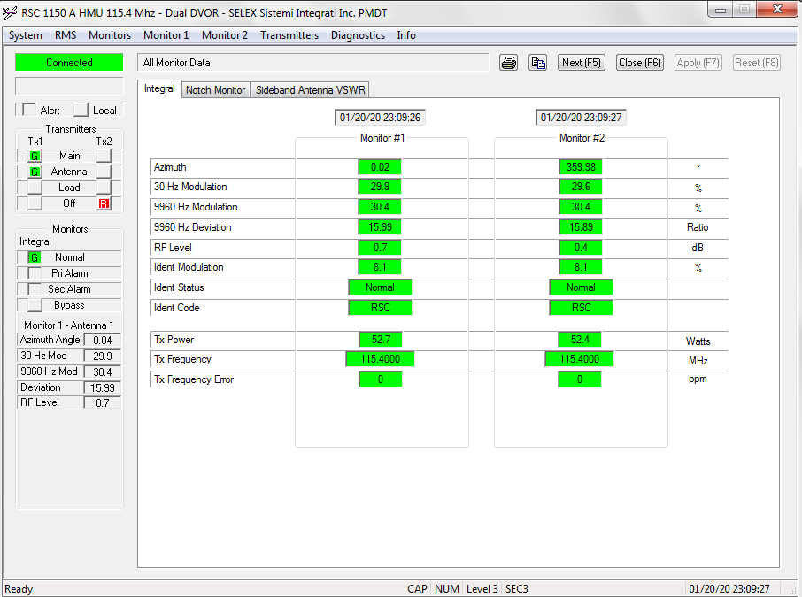

[10:27:32.057] F8 F8 C0 F0 08 00 00 00 00 97 00 14 01 14 17 1C 19 00 00 C0 87 00 00 01 88 06 2B 05 09 95 00 00 00 00 00 00 00 00 00 00 00 00 00 00 00 00 00 00 00 00 00 9C 8C 30 01 25 01 32 06 02 00 00 00 00 00 00 00 00 00 00 00 00 00 00 00 00 00 00 00 00 00 00 00 00 00 00 00 0C 00 00 00 00 00 00 00 00 00 00 00 00 00 00 00 00 00 00 00 00 00 00 00 00 00 00 00 00 00 00 00 00 00 00 00 00 00 00 00 00 00 00 00 00 00 00 00 00 00 00 00 00 00 00 00 00 00 00 00 00 00 00 4C 00 00 00 A7 D1 44 78 6F FB 2D 35 32 B4

1150A VOR

Tx2Ant ON

Tx2Main ON

Tx2On ON

DualEquipment ON

Vor eMain

VOR Go condition

Ngay 20 thang 1 nam 20 Gio 23 Phut 28 Giay 25

AzimuthAngle: 35996

Mod30Hz: 304

Mod9960Hz: 293

Deviation :1586

RFlevel: 2

V2 TX2

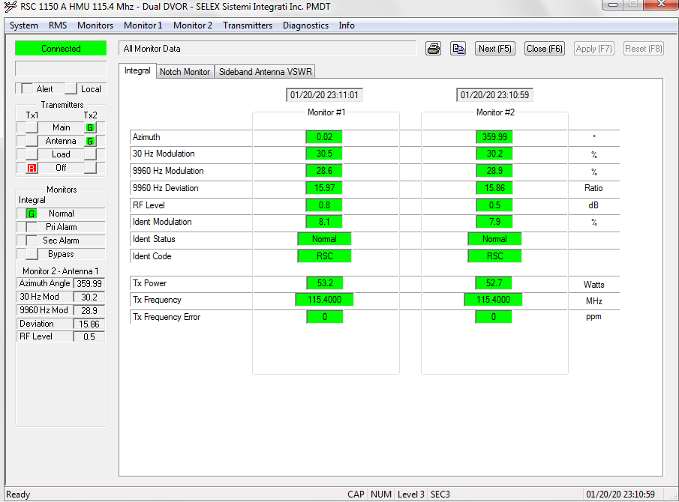

[10:27:01.503] F8 F8 C0 F0 08 00 00 00 00 97 00 14 01 14 17 1B 36 00 00 C0 87 00 00 01 88 06 2B 05 09 95 00 00 00 00 00 00 00 00 00 00 00 00 00 00 00 00 00 00 00 00 00 95 8C 30 01 25 01 32 06 02 00 00 00 00 00 00 00 00 00 00 00 00 00 00 00 00 00 00 00 00 00 00 00 00 00 00 00 0C 00 00 00 00 00 00 00 00 00 00 00 00 00 00 00 00 00 00 00 00 00 00 00 00 00 00 00 00 00 00 00 00 00 00 00 00 00 00 00 00 00 00 00 00 00 00 00 00 00 00 00 00 00 00 00 00 00 00 00 00 00 00 48 00 00 00 B7 C5 44 78 6F FB 2D 35 7F 11

1150A VOR

Tx2Ant ON

Tx2Main ON

Tx2On ON

DualEquipment ON

Vor eMain

VOR Go condition

Ngay 20 thang 1 nam 20 Gio 23 Phut 27 Giay 54

AzimuthAngle: 35989

Mod30Hz: 304

Mod9960Hz: 293

Deviation :1586

RFlevel: 2

TX2 ROI BAT BYPASS LEN

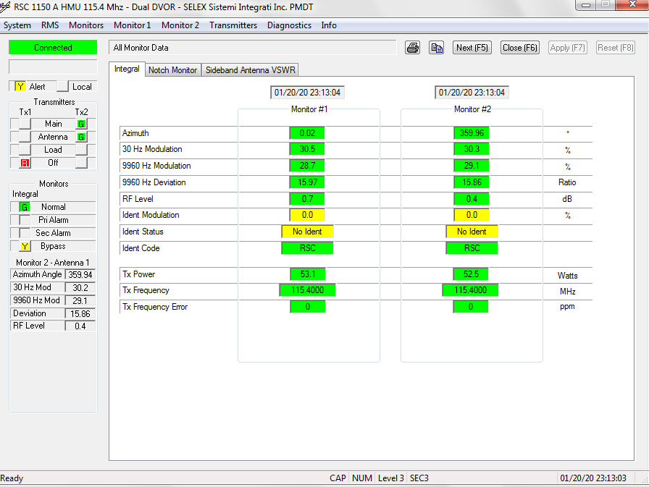

[10:25:55.382] F8 F8 C0 F0 08 00 00 00 00 97 00 14 01 14 17 1A 31 00 00 C1 87 00 01 01 98 06 2B 05 09 95 00 00 00 00 00 00 00 00 00 00 00 00 00 00 00 00 00 00 00 00 00 9A 8C 30 01 24 01 32 06 02 00 00 00 00 00 00 00 00 00 00 00 00 00 00 00 00 00 00 00 00 00 00 00 00 00 00 00 0C 00 00 00 00 00 00 00 00 00 00 00 00 00 00 00 00 00 00 00 00 00 00 00 00 00 00 00 00 00 00 00 00 00 00 00 00 00 00 00 00 00 00 00 00 00 00 00 00 00 00 00 00 00 00 00 00 00 00 00 00 00 00 17 00 00 00 E3 AB 44 78 6F FB 2D 35 DD F7

1150A VOR

Tx2Ant ON

Tx2Main ON

Tx2On ON

DualEquipment ON

IntMonBypass ON

Vor eMain

VOR Go condition

Ngay 20 thang 1 nam 20 Gio 23 Phut 26 Giay 49

AzimuthAngle: 35994

Mod30Hz: 304

Mod9960Hz: 292

Deviation :1586

RFlevel: 2

V4 XONG OFF TAT

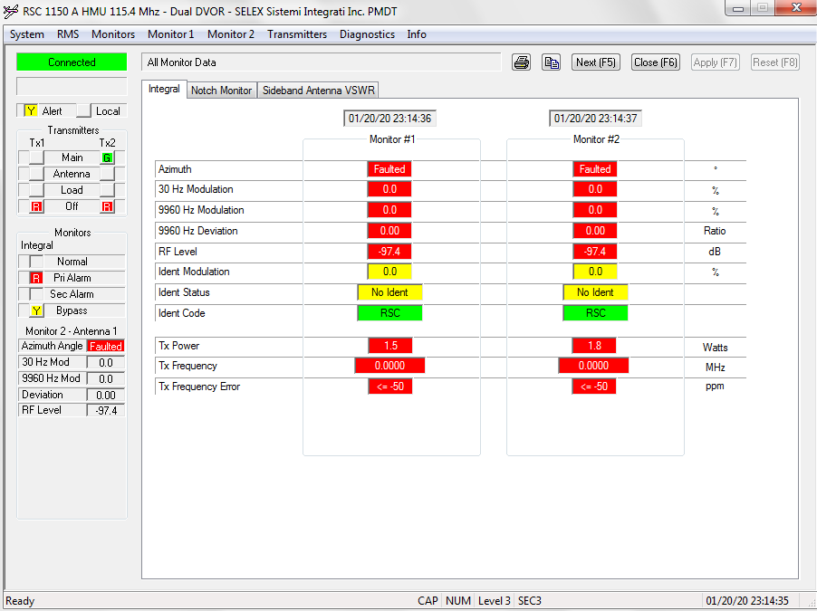

1150A VOR

Tx1Ant ON

Tx1Main ON

DualEquipment ON

IntMonBypass ON

IntPriAlarm ON

eOFF

VOR No Go condition ALARM

Ngay 20 thang 1 nam 20 Gio 23 Phut 24 Giay 57

AzimuthAngle: 65535

Mod30Hz: 0

Mod9960Hz: 0

Deviation :0

RFlevel: -974

XONG BAT VE BINH THUONG

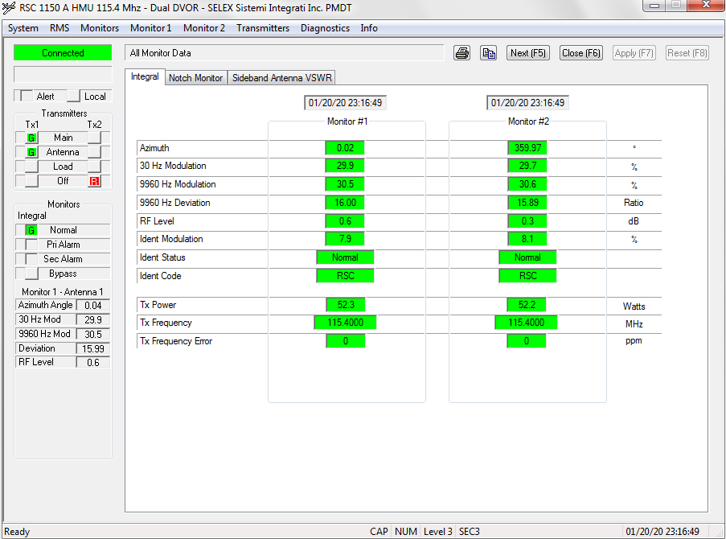

[10:22:24.523] F8 F8 C0 F0 08 00 00 00 00 97 00 14 01 14 17 17 12 00 00 C0 A7 00 00 01 87 06 2B 05 09 95 00 00 00 00 00 00 00 00 00 00 00 00 00 00 00 00 00 00 00 00 00 05 00 2C 01 32 01 3F 06 05 00 00 00 00 00 00 00 00 00 00 00 00 00 00 00 00 00 00 00 00 00 00 00 00 00 00 00 00 0E 00 00 00 00 00 00 00 00 00 00 00 00 00 00 00 00 00 00 00 00 00 00 00 00 00 00 00 00 00 00 00 00 00 00 00 00 00 00 00 00 00 00 00 00 00 00 00 00 00 00 00 00 00 00 00 00 00 00 00 00 00 10 00 00 00 85 59 44 78 6F FB 2D 35 9B 33

1150A VOR

Tx1Ant ON

Tx1Main ON

Tx1On ON

DualEquipment ON

Vor eMain

VOR Go condition

Ngay 20 thang 1 nam 20 Gio 23 Phut 23 Giay 18

AzimuthAngle: 5

Mod30Hz: 300

Mod9960Hz: 306

Deviation :1599

RFlevel: 5